CREATE TABLE Station

(

ID NUMBER NOT NULL,

CITY CHAR(20),

STATE CHAR(2),

LAT_N NUMBER,

LONG_W NUMBER,

CONSTRAINT ST primary key(ID)

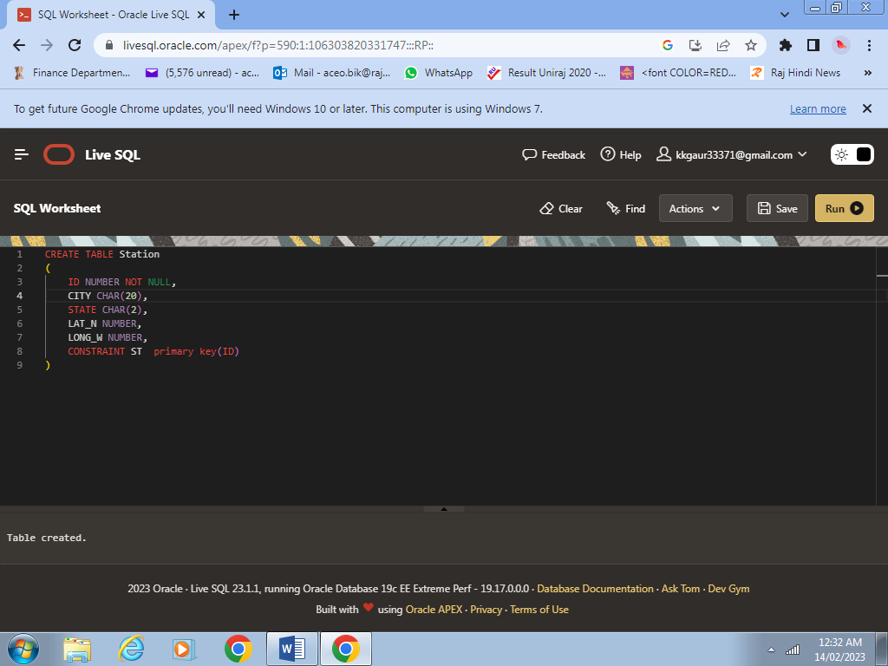)

INSERT INTO Station (ID,CITY,STATE,LAT_N,LONG_W ) VALUES('13','PHOENIX','AZ','33','112')

INSERT INTO Station (ID,CITY,STATE,LAT_N,LONG_W ) VALUES('44','DENVER','CO','40','105')

INSERT INTO Station (ID,CITY,STATE,LAT_N,LONG_W ) VALUES('66','CARIBOU','ME','47','68')

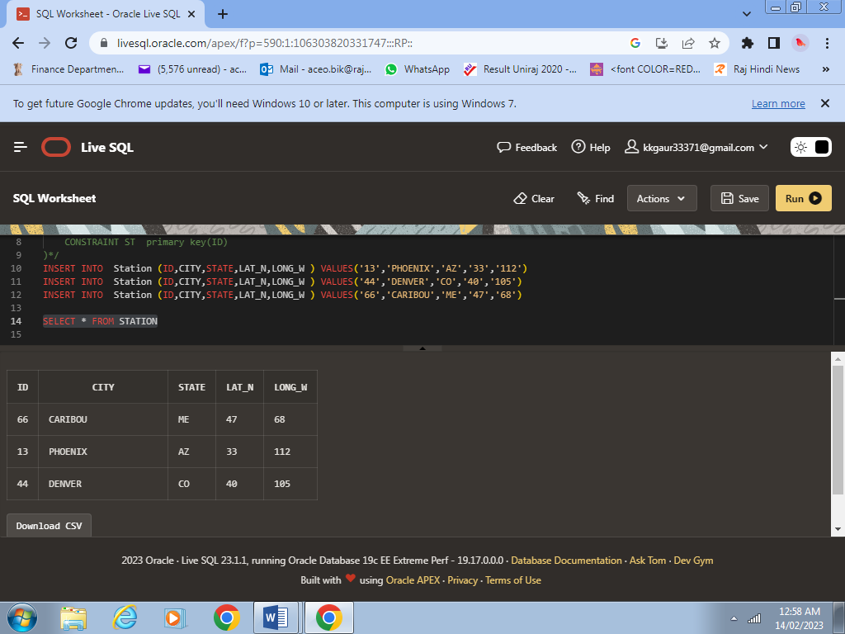

1. SELECT * FROM STATION

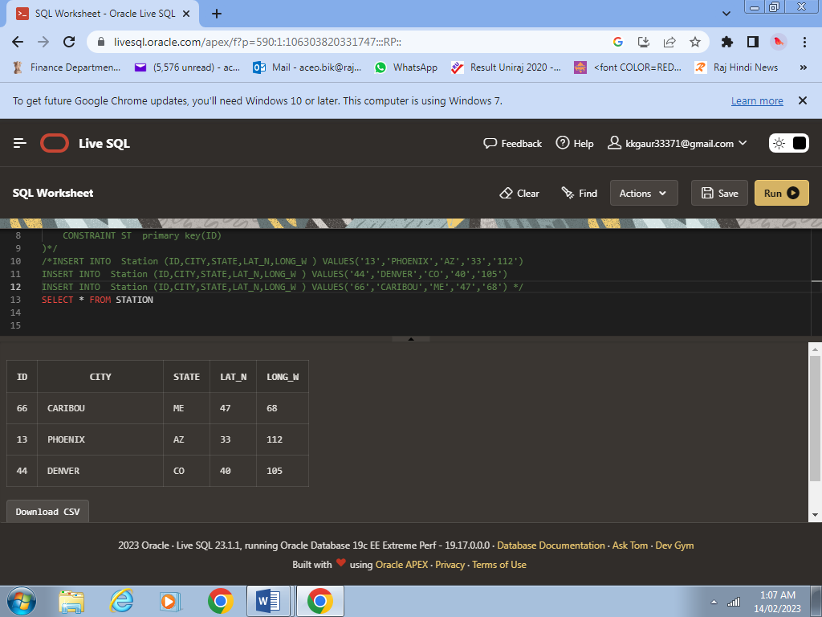

SELECT CITY, LAT_N AS Northern_stations FROM STATION

WHERE LAT_N > 39.7 ;

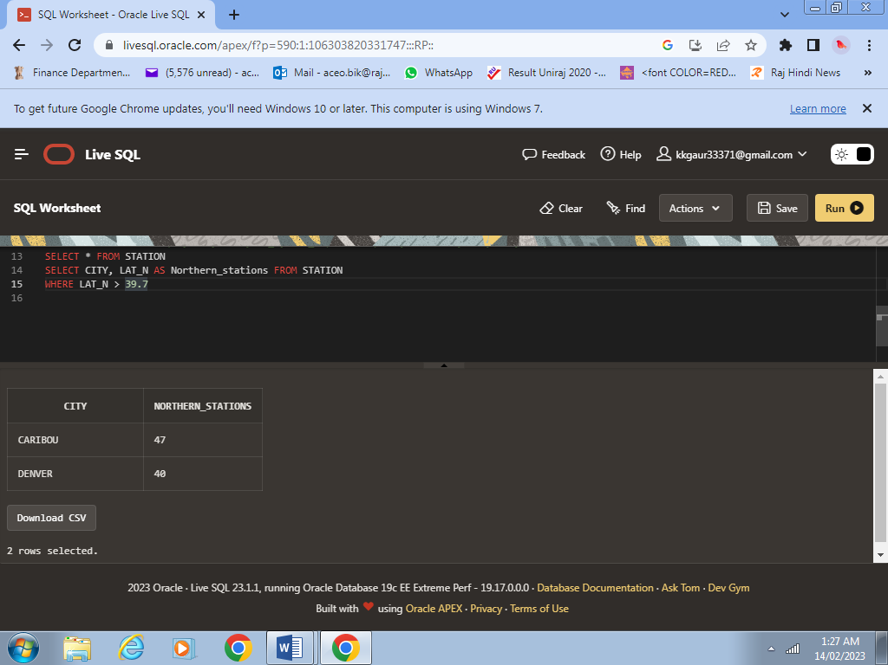

CREATE TABLE STATS

(

ID NUMBER NOT NULL,

MONTH NUMBER CHECK (MONTH BETWEEN 1 AND 12),

TEMP_F NUMBER CHECK (TEMP_F BETWEEN -80 AND 150) ,

RAIN_I NUMBER CHECK (RAIN_I BETWEEN 0 AND 100) ,

CONSTRAINT STA PRIMARY KEY (ID,MONTH),

CONSTRAINT STAA FOREIGN KEY (ID) REFERENCES STATION(ID)

)

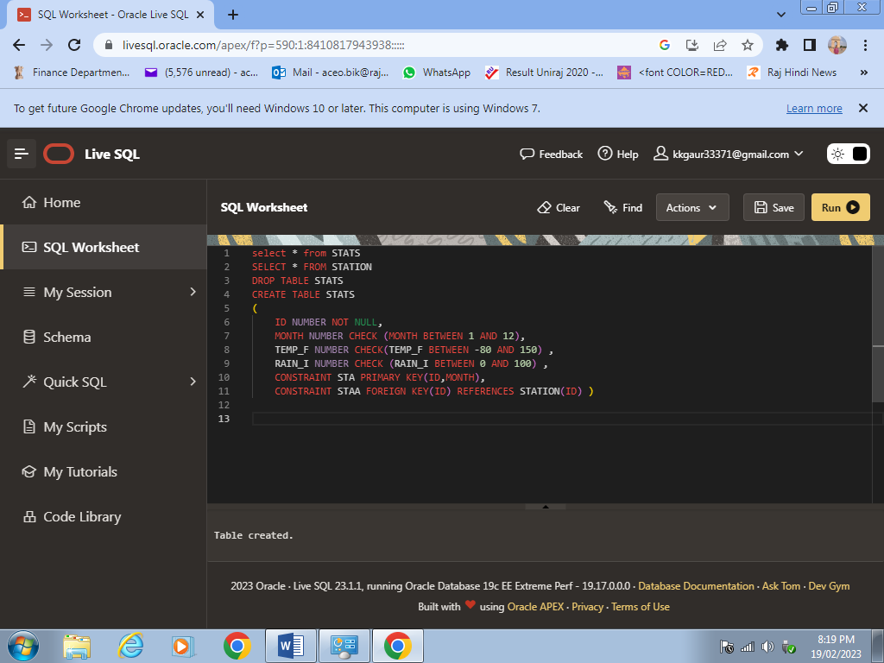

INSERT INTO STATS (ID,MONTH,TEMP_F,RAIN_I) VALUES(13,1,57.4,.31)

INSERT INTO STATS (ID,MONTH,TEMP_F,RAIN_I) VALUES(13,7,91.7,5.15)

INSERT INTO STATS (ID,MONTH,TEMP_F,RAIN_I) VALUES(44,1,27.3,.18)

INSERT INTO STATS (ID,MONTH,TEMP_F,RAIN_I) VALUES(44,7,74.8,2.11)

INSERT INTO STATS (ID,MONTH,TEMP_F,RAIN_I) VALUES(66,1,6.7,2.1)

INSERT INTO STATS (ID,MONTH,TEMP_F,RAIN_I) VALUES(66,7,65.8,4.52)

SELECT * FORM STATS

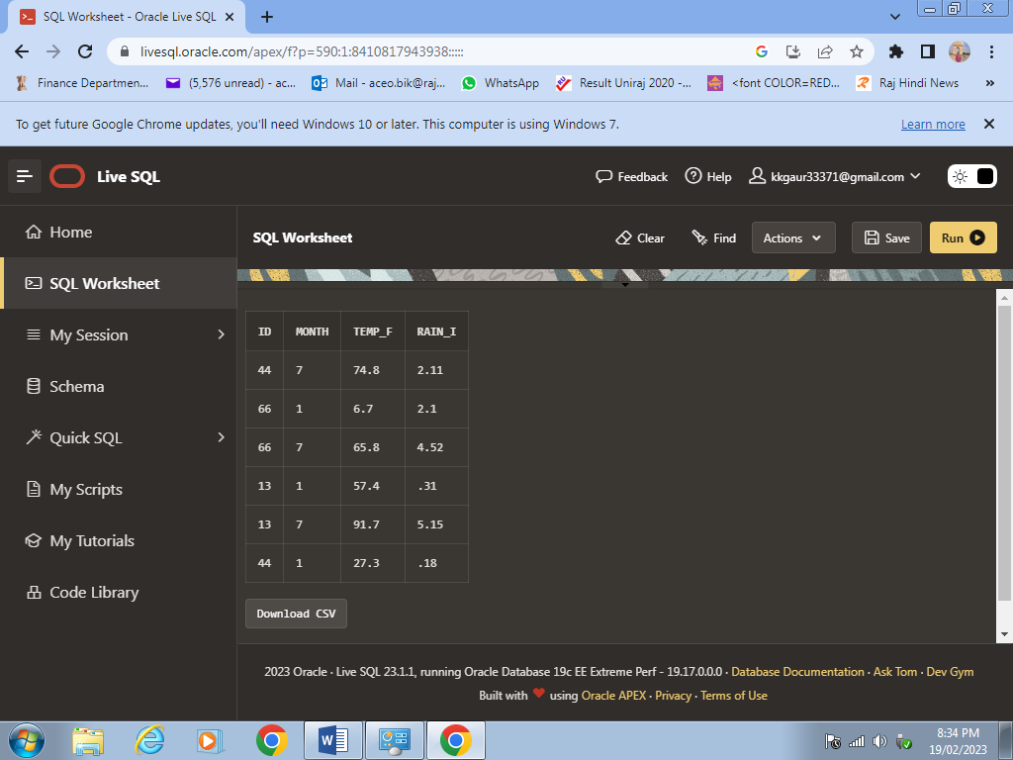

1. SELECT CITY, TEMP_F, MONTH FROM STATION A INNER JOIN STATS B

ON A.ID = B.ID

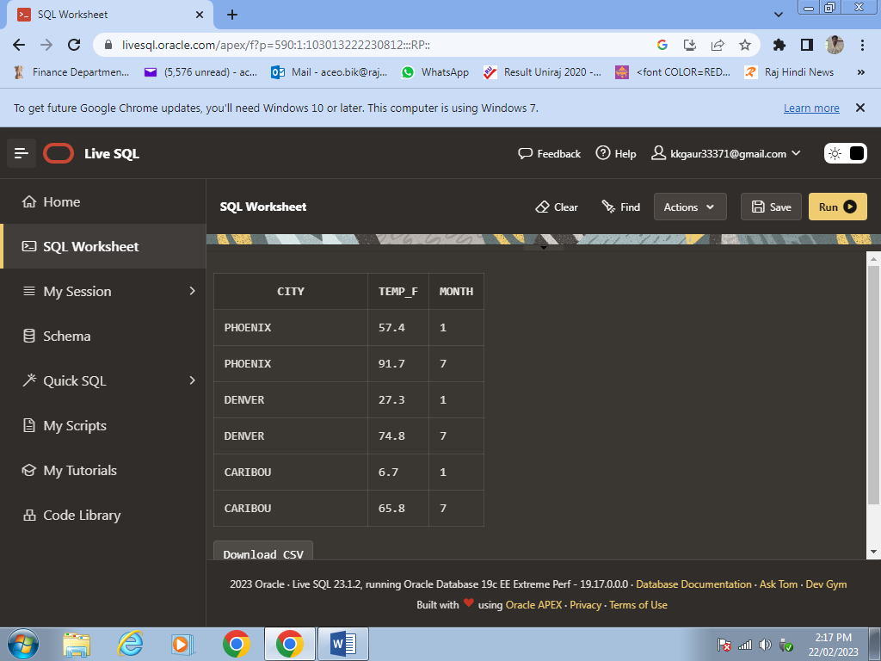

1. SELECT CITY,MONTH, RAIN_I AS GREATEST_RAINFALL FROM STATION A INNER JOIN STATS B ON A.ID =B.ID

ORDER BY RAIN_I DESC;

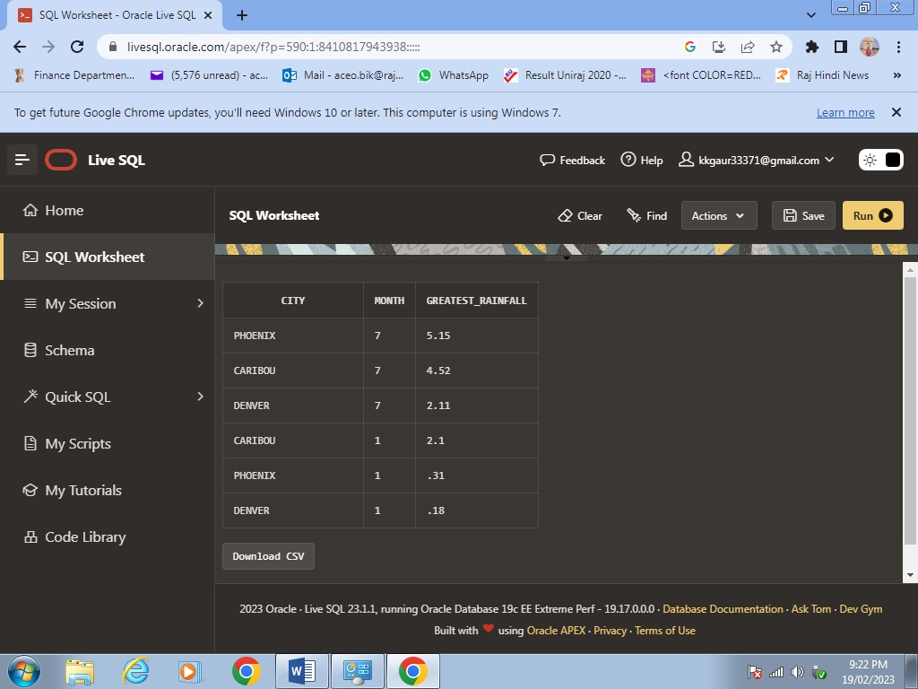

1. SELECT CITY,MONTH , TEMP_F,LAT_N FROM STATION A INNER JOIN STATS B ON A.ID =B.ID

WHERE MONTH = '7'

ORDER BY TEMP_F;

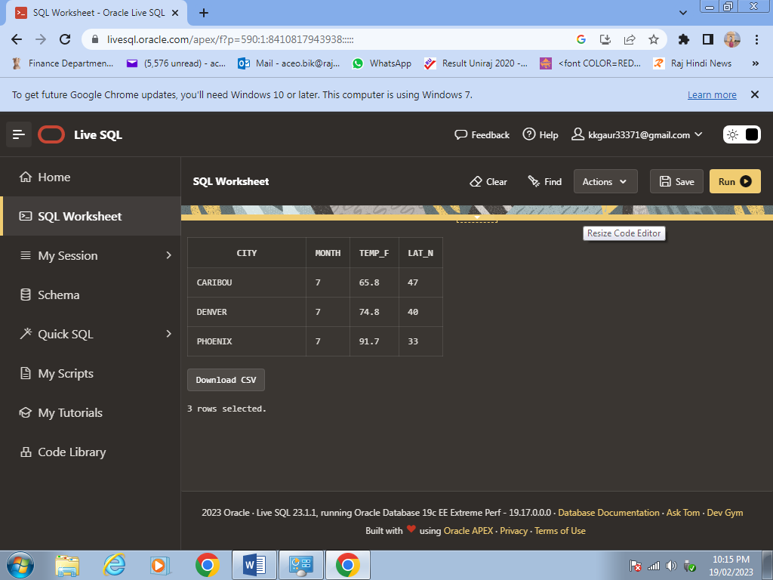

1. SELECT CITY, MAX(TEMP_F),MIN(TEMP_F),AVG(RAIN_I) FROM STATION A INNER JOIN STATS B ON A.ID =B.ID

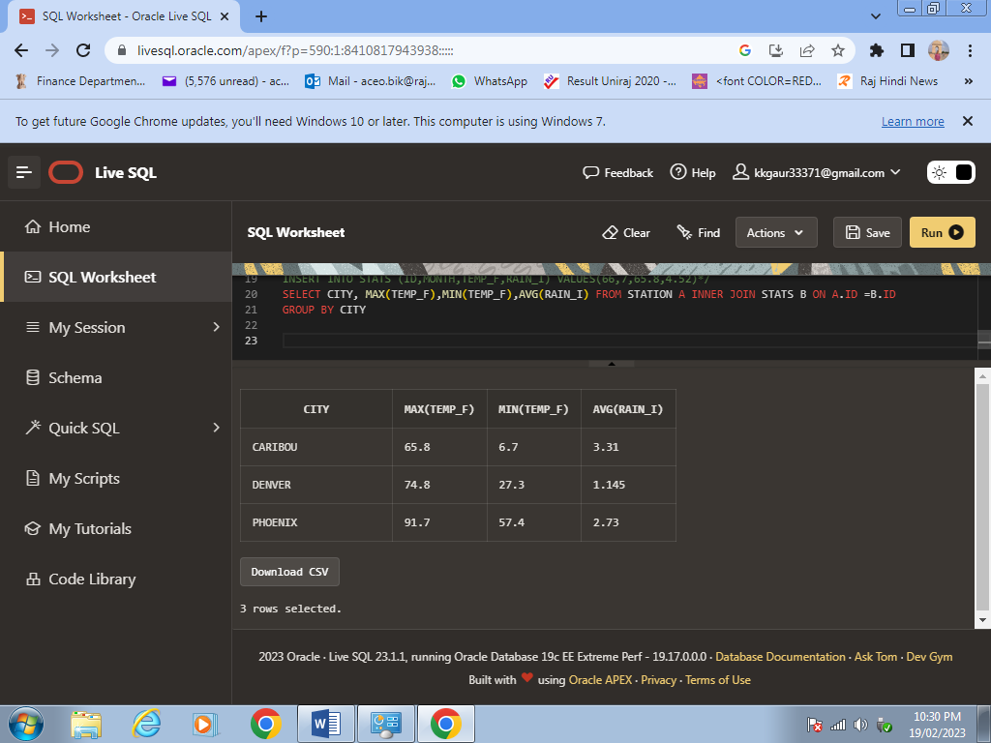GROUP BY CITY;

SELECT CITY,MONTH, ROUND((TEMP_F-32)*5/9,2) AS TEMP_IN_CELCIUS,

**RAIN_I*2.54 AS RAIN_IN_CENTIMETER FROM**

STATION A INNER JOIN STATS B ON A.ID = B.ID

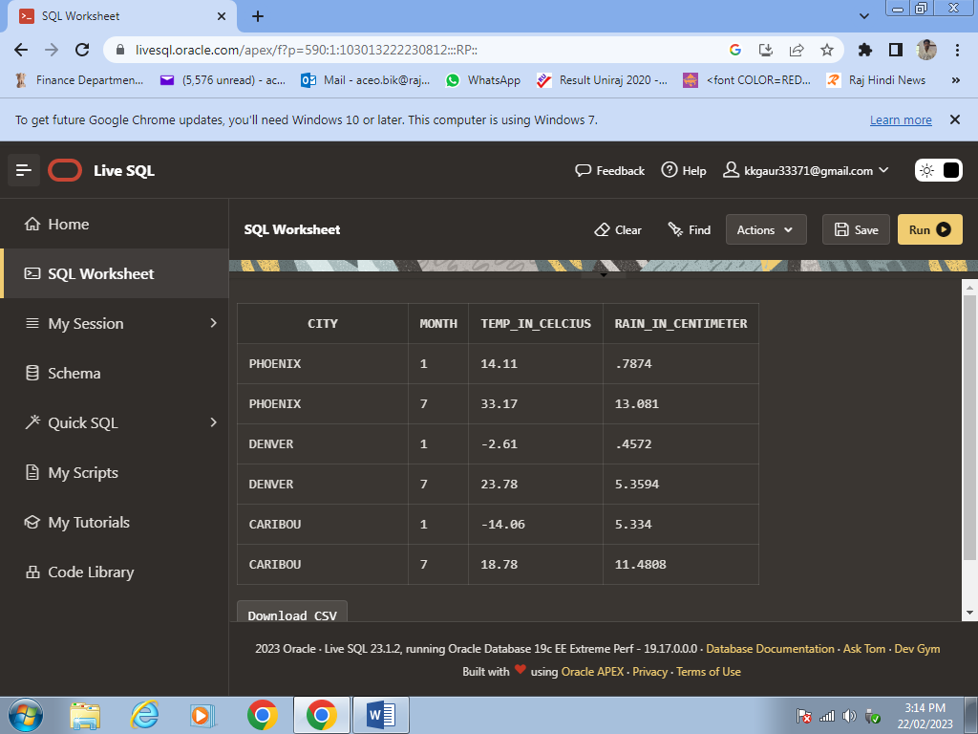

UPDATE STATS

SET RAIN_I = RAIN_I+0.01

WHERE ID = 13

UPDATE STATS

SET RAIN_I = RAIN_I+0.01

WHERE ID = 44

UPDATE STATS

SET RAIN_I = RAIN_I+0.01

WHERE ID = 66

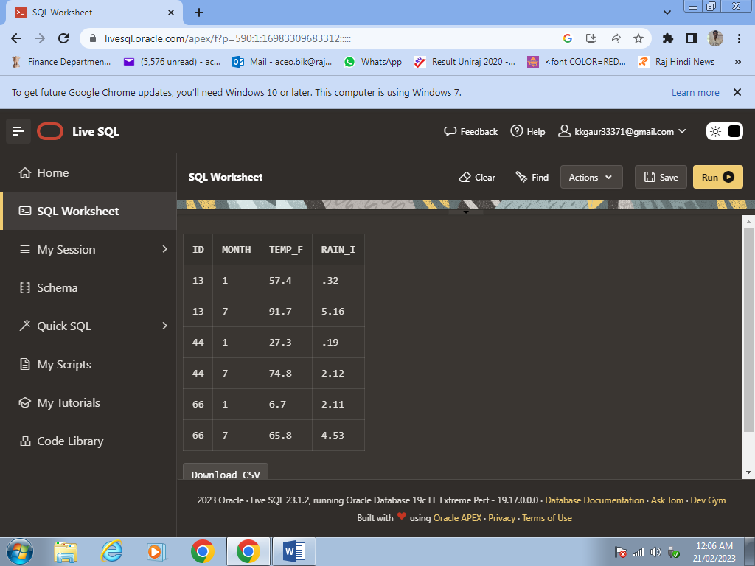

UPDATE STATS

SET TEMP_F = '74.9'

WHERE ID= '44' AND MONTH = '7'

SELECT CITY,TEMP_F ,MONTH FROM STATION A INNER JOIN STATS B ON A.ID = B.ID

WHERE MONTH = '7' AND CITY ='DENVER'

